**DIGITAL MARKETING**

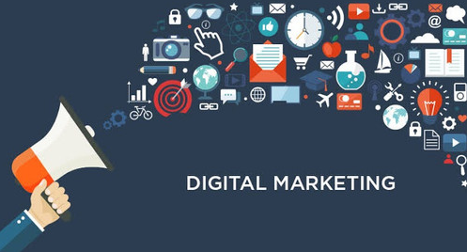

**“THE INTERNET IS BECOMING THE TOWM SQUARE FOR THE GLOBAL VILLAGE OF TOMORROW”**

**- BILL GATES**

***Digital marketing is one of the dominant way of marketing your ideas,business,utilities on internet and online based digital technologies.As we know that all are going through the most difficult pandemic situation,all are social distancing but your brand needs to be socially active.Digital marketing has become more than a need an effective tool that accelerate your results.there are many benefits of digital marketing such as:***

1. ***Affordability***
2. ***Mobile Access***
3. ***Flexibility***
4. ***Expansion***
5. ***Multimedia***
6. ***Interactivity….***

***Digital marketing also provides job opportunities to individuals.Any modern brand that wants to get ahead in the current business climate will need to adopt digital marketing tactics as part of their overall strategy.However,by using digital marketing tactics in combination with your current traditional marketing strategies,your business can start to optimize your campaigns for maximum results.Digital marketing, also called online marketing, is the promotion of brands to connect with potential customers using the internet and other forms of digital communication. This includes not only*** [***email***](https://mailchimp.com/email-marketing/)***,*** [***social media***](https://mailchimp.com/marketing-glossary/social-media-marketing/)***, and web-based advertising, but also text and multimedia messages as a marketing channel.Essentially, if a marketing campaign involves digital communication, it's digital marketing.***